|  |  |
| --- | --- |
| **Boarding Pass (Web Check•in)** | **Your Departure terminal is T1** |
| **PRADHAN/DEBASHISH MR BENGALURU (T1)** To **BHUBANESHWAR (T1)**    Flight Gate Boarding Boarding Seat  **6E •** Time **Zone 4F**  **368 0525 3**  **Hrs**  Date **27 Nov 2021** Departure **0610 Hrs**  Seq **0012** Services **NIL**  Gate is subject to change and will close 25 minutes prior to departure | **PRADHAN/DEBASHISH MR** |
| **BENGALURU (T1)** To |
| **BHUBANESHWAR (T1)** |
| PNR **QGQWSY** |
| Flight **6E 368** |
| Date **27 Nov 2021** Services |
| **NIL** |
| Seat **4F** |
| Seq **0012** |
| **Boarding Pass (Web Check•in)** | **Your Departure terminal is T1** |
| **MOHANTY/MANJUSMITA MRS BENGALURU (T1)** To **BHUBANESHWAR (T1)**    Flight Gate Boarding Boarding Seat  **6E •** Time **Zone 4D**  **368 0525 3**  **Hrs**  Date **27 Nov 2021** Departure **0610 Hrs**  Seq **0013** Services **NIL**  Gate is subject to change and will close 25 minutes prior to departure | **MOHANTY/MANJUSMITA MRS** |
| **BENGALURU (T1)** To |
| **BHUBANESHWAR (T1)** |
| PNR **QGQWSY** |
| Flight **6E 368** |
| Date **27 Nov 2021** Services |
| **NIL** |
| Seat **4D** |
| Seq **0013** |
| **Boarding Pass (Web Check•in)** | **Your Departure terminal is T1** |



|  |  |  |  |  |  |  |  |  |
| --- | --- | --- | --- | --- | --- | --- | --- | --- |
|  |  |  |  |  |  |  |  |  |

|  |  |  |  |  |  |  |  |  |
| --- | --- | --- | --- | --- | --- | --- | --- | --- |
|  |  |  |  |  |  |  |  |  |

|  |  |  |  |  |  |  |  |  |
| --- | --- | --- | --- | --- | --- | --- | --- | --- |
| Flight  **6E**  **368** |  | Gate  **•** |  | Boarding Time  **0525**  **Hrs** |  | Boarding  **Zone 3** |  | Seat  **4E** |



**PRADHAN/SAI AYUSHMAAN CHD**

**BENGALURU (T1)** To

**BHUBANESHWAR (T1)**

PNR **QGQWSY**

Flight **6E 368**

Date **27 Nov 2021** Services

**NIL**

Seat **4E**

Seq **0014**

Advertisement



**PRADHAN/SAI AYUSHMAAN CHD**

**BENGALURU (T1)** To **BHUBANESHWAR (T1)**

Date **27 Nov 2021**

Seq **0014**

Departure **0610 Hrs**

Services

**NIL**

Gate is subject to change and will close 25 minutes prior to departure

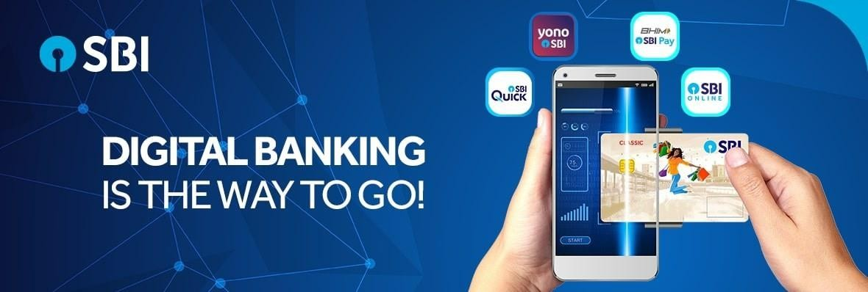

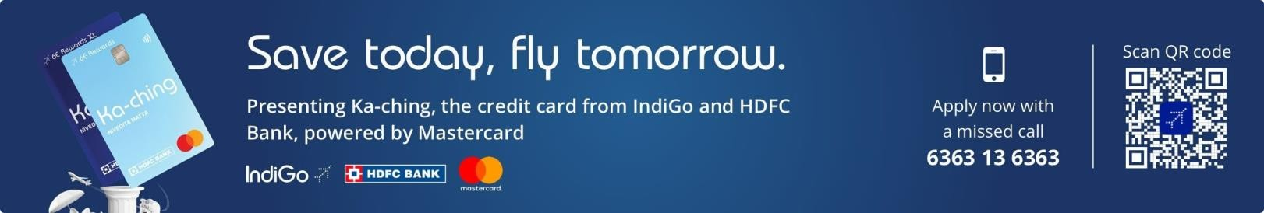

Travel advisory: Safety during COVID•19

**We seek your kind assistance to safeguard your well•being, as well as that of your fellow passengers and our crew on board our flights, by following the guidelines set out below:**

* IndiGo shall provide a **complimentary safety kit** (three layered surgical masks, a face shield, and a sanitizer) to all customers at the boarding gate.
* Customers seated in **middle seats** will also be provided additional protective equipment in the form of a **wrap•around gown.**
* All customers should wear a **mask, face shield, gown** (if applicable) and **sanitize their hands** before proceeding to the boarding gate.
* Customers must wear a **face mask** covering their nose and mouth, throughout their journey with IndiGo. The mask may be removed while eating and drinking.
* Please maintain appropriate **social distancing** while boarding and de•boarding the aircraft.
* Kindly adhere to all the announcements and other directives issued by our ground staff and/or crew at all points of time during your journey.
* Customers are also requested to familiarise themselves with the guidelines for air passengers published by the Indian Ministry of Civil Aviation on the following link:

[https://www.civilaviation.gov.in/sites/default/files/Guidelines_for_Air_Passengers_21May.pdf](http://t.marketing.goindigo.in/r/?id=h420bcf12%2C58edc7de%2C58edc804) • **Caution: Customers are advised to strictly follow all COVID•19 protocols. Failure to comply with these guidelines and the directions of our ground staff and/or crew may attract penal action against the concerned individual.**